Docs/PreMO/Grand AA Zenith/ Data spreadsheets / TWO TIME POINTS, Redcap Data Difference Visit

**Fig. 1**. MRI (top) with 3T resting state connectivity heat map. Boxes illustrate posterior cingulate cortex (PCC) and frontal cortex (FC) brain regions where 7T MRS (bottom) was acquired.

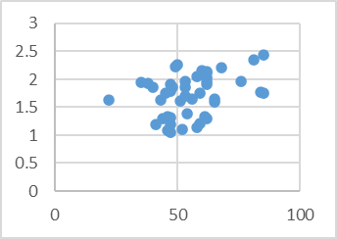

**Picture Sequence Memory**

**PCC PE Concentration (mM)**

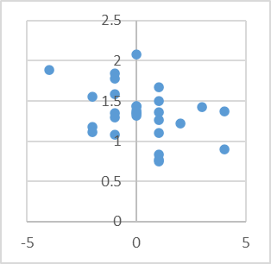

**PCC Asc Concentration (mM)**

**∆memory**

FC Asc and ∆ TMTA (r = 0.31) and FC PE and TMTA (r = 0.37).

**Fig. 3.** Concentration of the neuronal health marker NAA in cognitively healthy participants age 60-89 who were β-amyloid PET positive (n=5) was higher (p=0.02) than those who were negative (n=11).

**Fig. 2**. Age course of key PCC neurochemical concentrations (n=46 total, mean and SD per decade). Cho: choline, Glu: glutamate. Quantification of Asc and PE is novel.

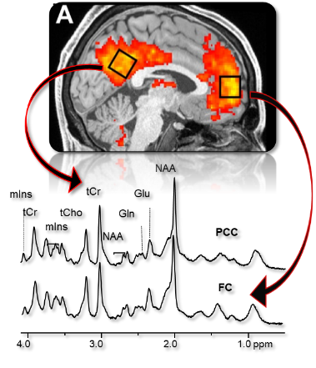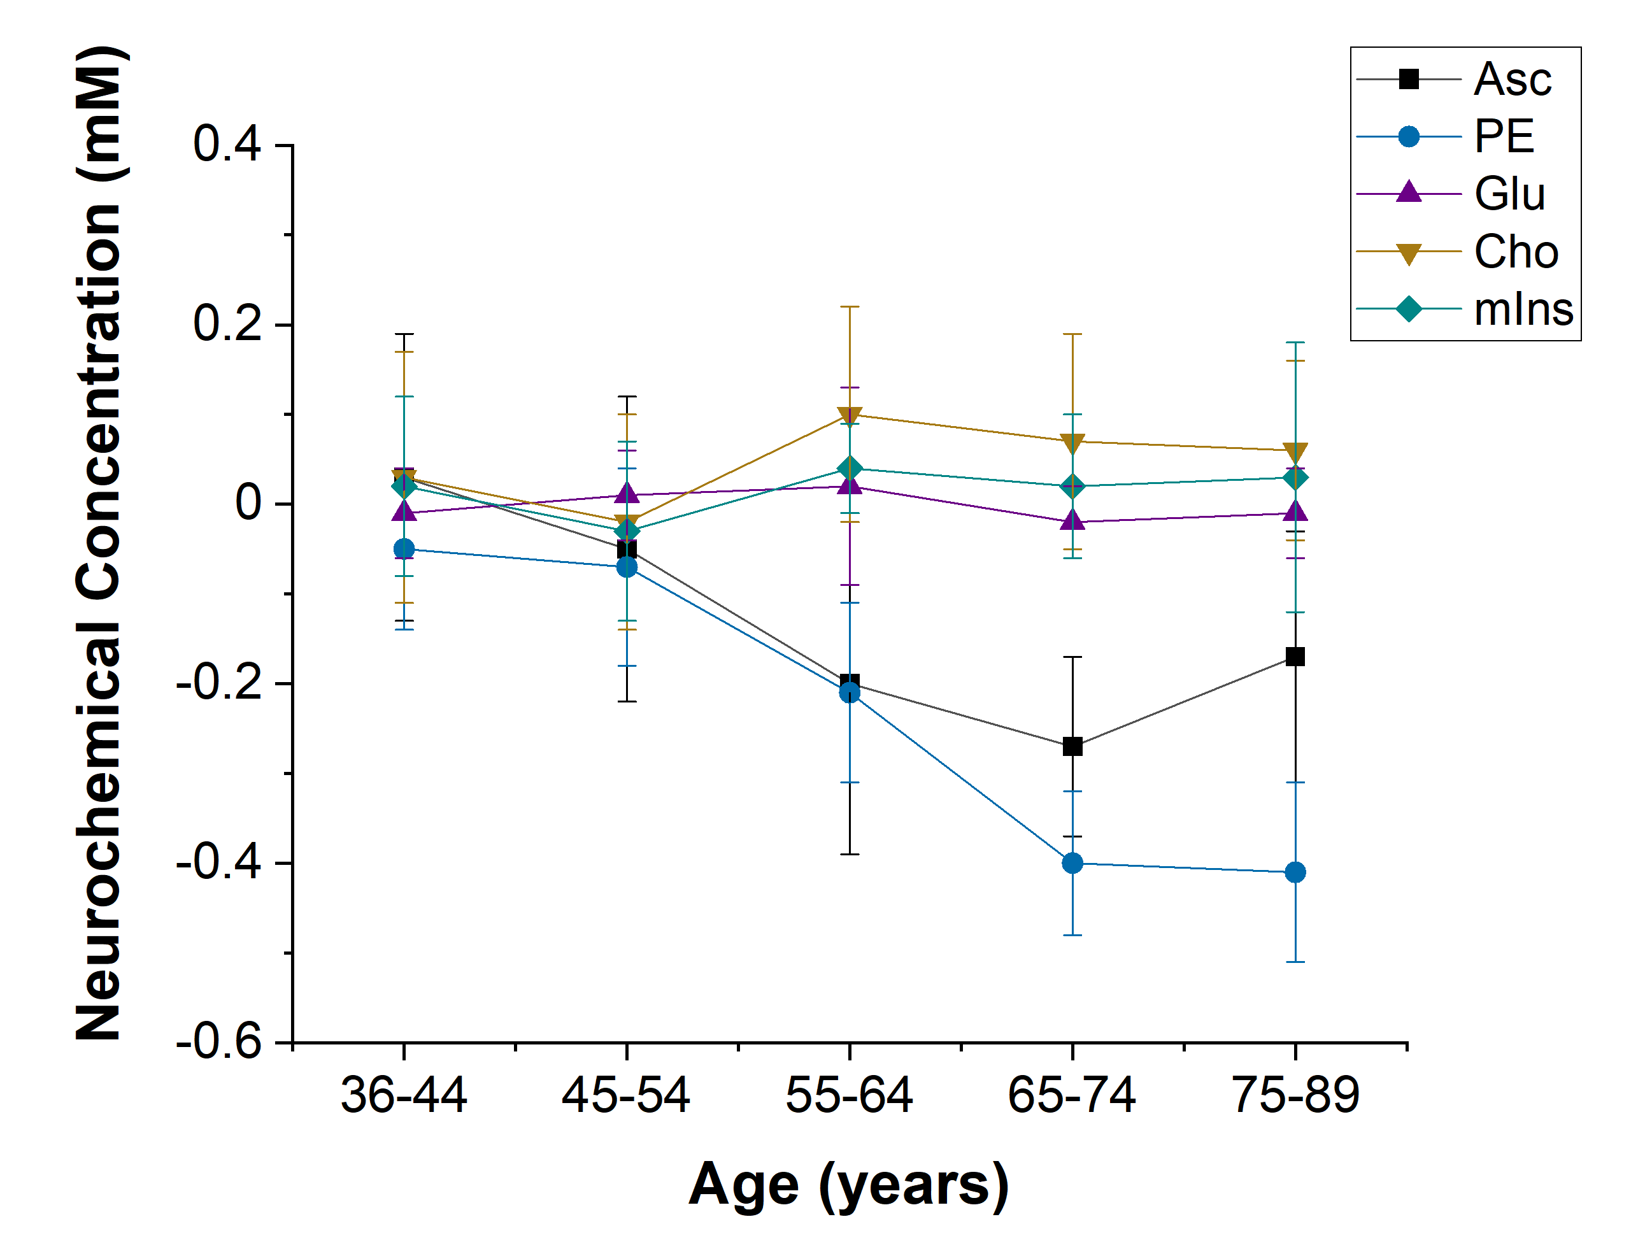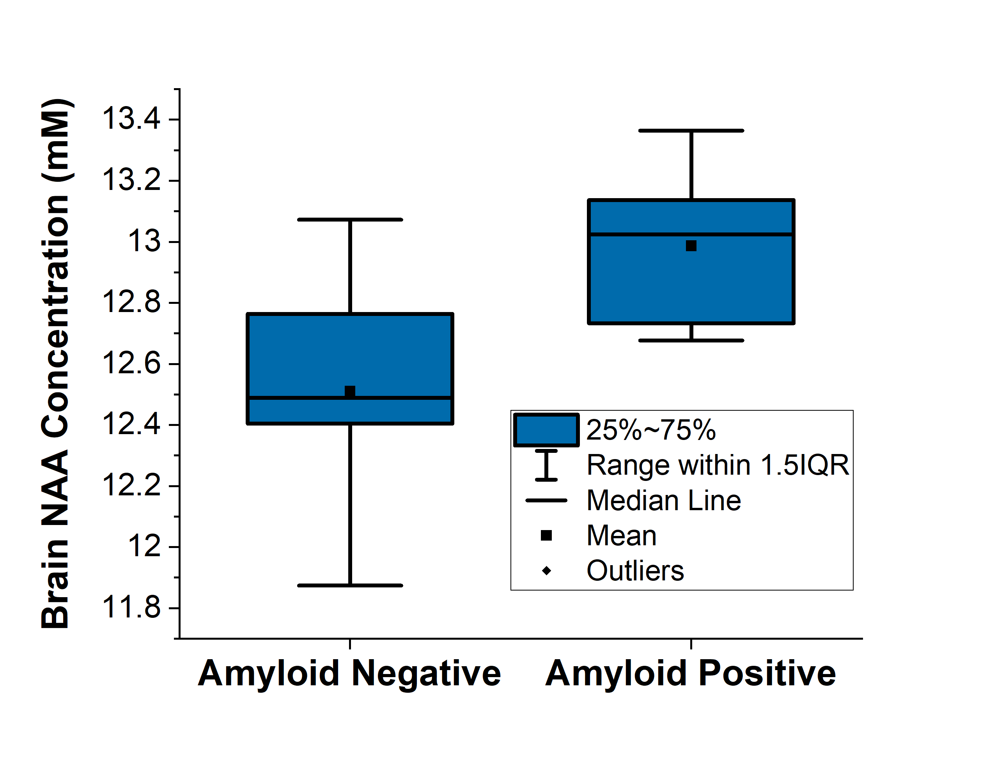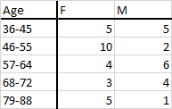

**Table 1. Demographic distribution of typically aging cohort. Number of participants by age (years), female (F) and male (M)**

Collaborate and Hire/ Undergraduate/ Hassler tNAA data

Docs/PreMO/2020 Talks/ Juchem/ Age summary data to add error bars

Docs/PreMO/Grand AA Zenith/ Data spreadsheets / ONE TIME POINT

Docs/PreMO/Grand AA Zenith/ Data spreadsheets / TWO TIME POINTS

Docs/PreMO/Grand AA Zenith/ Data spreadsheets / ONE TIME POINT

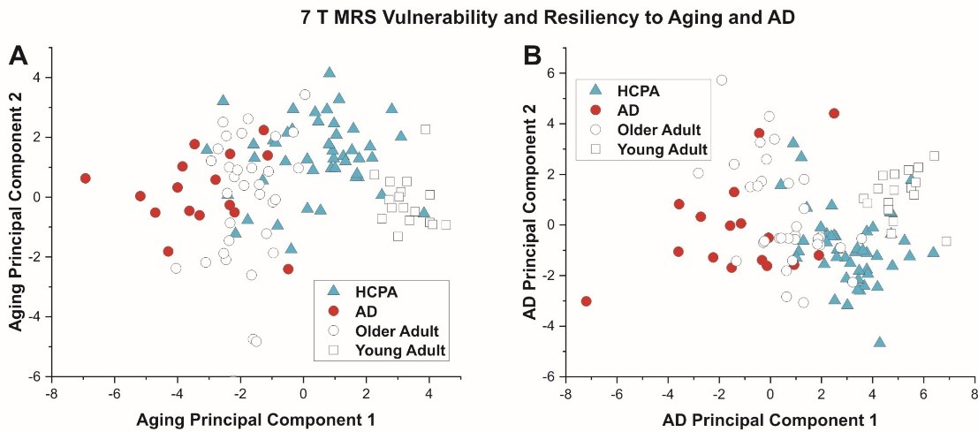

**Pre Missouri/ Grant AABC/ MRS for projects/ MRS PC and RF aging AD HCPA**

1. **Prin 1 2 x Prin 2 2**
2. **Prin 1 3 by Prin 2 3**
3. **HCPA = Dataset Aging**
4. **AD = Elderly AD (Group dataset)**
5. **Older Adult = Elderly Aim 1 and Elderly Aim 2**
6. **Young Adult = Young Aim 1**

Docs/2022 ISMRM abstract/ PCMRS PRS CogComp worksheet Prelim Data Pull 201229

Docs/PreMO/Grand AA Zenith/ Data spreadsheets / TWO TIME POINTS

**Table 2.** Correlation coefficients (r) among the MRS-based indices of aging and AD, polygenic risk score with and without APOE status included and composite scores for memory and executive function.

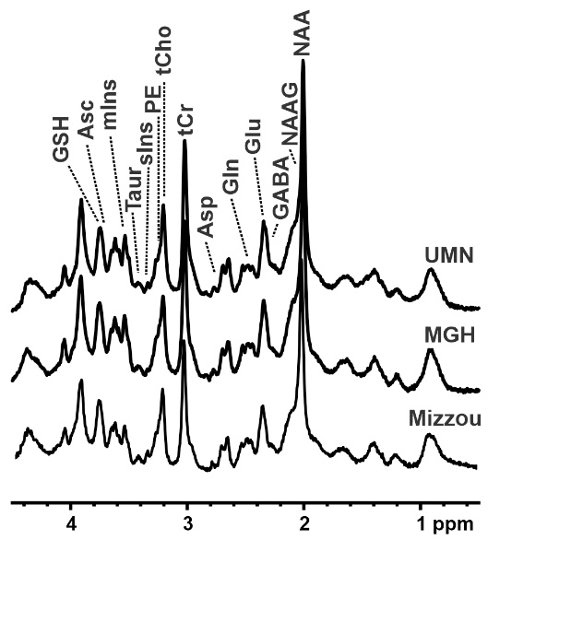

**Figure 8.** 7T MRS measured using the protocol of this proposal at multiple sites including the University of Missouri (Mizzou), illustrating that this project is ready to run once funds are transferred.